# **Department of Computer Science and Engineering Islamic University of Technology (IUT)** A subsidiary organ of OIC

# **Laboratory Report**

# CSE 4412: Data Communication and Networking Lab

## 

|  |  |
| --- | --- |
| **Name** | **: Chowdhury Ashfaq** |
| **Student ID** | **: 200042123** |
| **Section** | **:A** |
| **Semester** | **:Winter** |
| **Academic Year** | **: 2023** |
| **Date of Submission** | **: 15/01/23** |
| **Lab No** | **: 1** |

### 

### **Title:** Introduction to different transmission media and crimping of RJ45 Connector to UTP cable

### **Objective**:

1. Introduction to different guided media such as UTP, Coaxial Cable, Optical fiber.
2. Internal arrangement of UTP cables.
3. Different Wiring pattern Standard such as T568A or T568B.
4. Different types of cabling for UTP such as straight through, crossover and roll over, and their usage.
5. Procedure to crimp RJ45 connector to UTP cable.
6. Procedure to check the connection.

### **Devices Used in the experiment:** CAT-6 Cable, RJ45 Connector, Crimping Tool

### **Theory:**

At first we were introduced to the types of cabling like straight-through, cross-over, and roll-over. We mainly worked with cross-over cable in the lab. Again there are twisted pair cable which can further be divided into two types, Unshielded Twisted Pair which is most common and Shielded Twisted Pair.

Every cable has a structure of its own. Like the UTP has a color coded insulation surrounded by an outer jack while STP has pair shields. UTP cable is further divided into 7 types according to which we can select the cable during work.

Our main goal of the lab was to learn a wiring process of the cable. There are two wiring schemas we got introduced to, TIA/EIA 568A and TIA/EIA 568B. The difference between the two is in the order in which color-coded pairs are connected. There’s a traditional way in which the colored wires are connected to the pins of the RJ45 connector which have been demonstrated with a picture below:

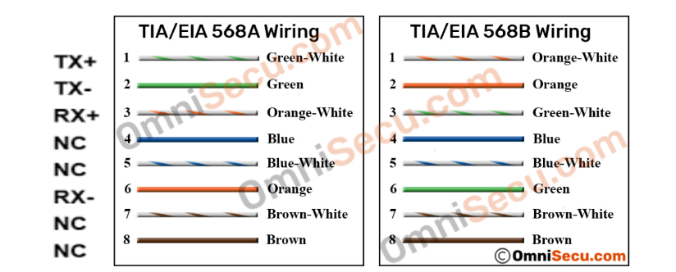

Next we move on to straight-through and crossover cable. In straight-through the convention doesn’t matter because same color wire connects to the same pin at both end of the RJ45 connector. Straight-through cable is easy to setup.

In Crossover cable, the color-coded wires at one end of the RJ45 connector is connected to other pin number of the RJ45 connector at other end. The convention that’s followed is T568A and T568B.

There are 8 color-coded wires in each cable but all of them doesn’t have a function. There are extra 4 wires which are 4,5,7 and 8 in T568A. These are kept as safety or backup considering if other wires break during transportation or any other reason.

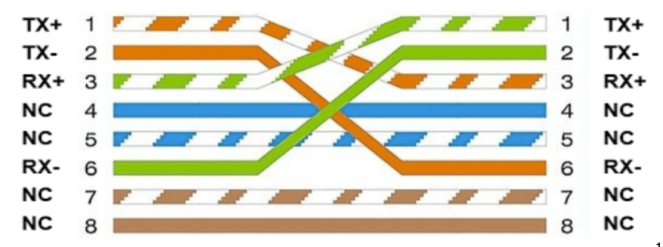

Straight-through cables are used to connect different devices like PC and switch but crossover cable is used to connect similar devices like PC to PC.

### **Working Procedure:**

* At first we stripped a part from the outer layer of the UTP cable to get the colored wires.
* Then we separated the 8 wires from each other and straightened them perfectly so that they don’t twist again.
* Next we align or separate the 4 pairs according to color.
* Then we align each of the wires according to T568A orientation.
* To make the edges of the wires straight, we cut all of the wires with a single blade holding the wires at the neck.
* Next we insert the wires carefully into the RJ45 connector making sure that the wires are correctly inserted into the pins.
* Insert the RJ45 connector in the crimping tool and then applied pressure as much as we could so that the wires setup perfectly.
* Followed the same procedure for other end of the cable following T568B protocol.
* Lastly, to verify if the cable is working we tested it with a crimping tool.

### **Diagram of the experiment:**

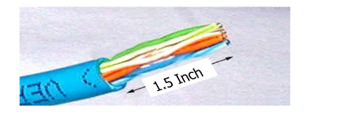

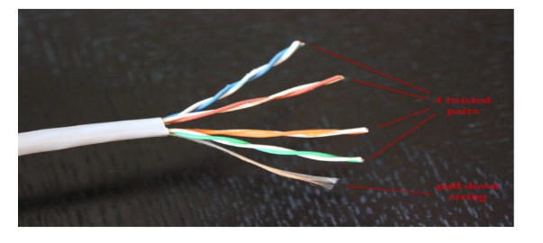

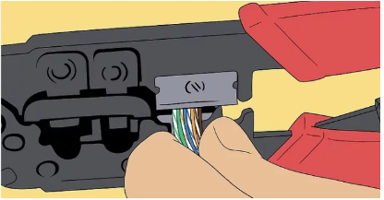

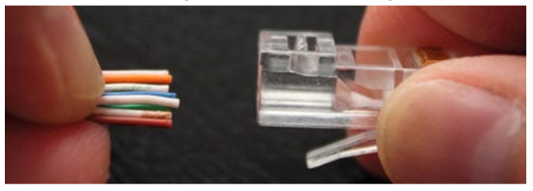

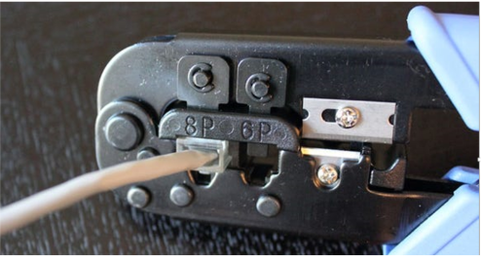

### **Observation**:

* Verification of wiring can be done by observing the order of the wires.
* Main purpose is to avoid data loss during transmission.

### **Challenges:**

* Faced difficulty in cutting outer portion of cable with crimping tool.
* Faced problem to cut the edges of the wire straightly.
* The wires don’t insert in the pins of RJ45 connector properly.
* Using crimping tool for the first time was troublesome.